**CIS 5200 Term Project Tutorial**

**Flight Prices Analysis**

**Authors:** Ragi Dave, An Mach, Ankita Hasmukhbhai Savaliya, Bhumika Suvagia

**Instructor:** Dr. Jongwook Woo

Date:05/17/2023

1. **Objectives**

In this hands-on lab, you will learn how to:

* Upload the data into HDFS using -put command.
* Create Hive tables and perform data engineering in Hive using HiveQL
* Query data using HiveQL
* Secure copy tables created with HiveQL from Hadoop to local computers
* Create visualizations

1. **Platform Specifications**

hdfs version



lscpu

hdfs dfsadmin -report

* Cluster Version: Hadoop 3.1.2
* CPU Speed: 1995.312 MHz
* Number of CPU cores: 8 cores * 5 nodes = 40 cores
* Number of nodes: 5 (2 Master and 3 Worker)
* Total Memory Size: 390.71 GB

**3. Steps to download Kaggle datasets in Google Colab** (<https://www.kaggle.com/general/156610>)

**Note: We realized the steps in this section are not necessary in this project. We could have downloaded the zip file directly from Kaggle then unzip the file on a local computer. You can move to section 4.**

1. Go to your kaggle account, Scroll to API section and Click Expire API Token to remove previous tokens

2. Click on Create New API Token - It will download kaggle.json file on your machine.

3.Go to your Google Colab project file and run the following commands to mount your Google Drive files Following code make mount your google drive

from google.colab import drive

drive.mount('/content/gdrive')

• Now upload the kaggle.json file

from google.colab import files

files.upload() #this will prompt you to upload the kaggle.json

• make sure kaggle.json file is present

!ls -lha kaggle.json

• Install kaggle API client

!pip install -q kaggle

• kaggle API client expects the file to be in ~/.kaggle

• so move it there

!mkdir -p ~/.kaggle

!cp kaggle.json ~/.kaggle/

• we need to set permissions

!chmod 600 /root/.kaggle/kaggle.json

• check your directory before downloading the datasets

!pwd

• list all available datasets

!kaggle datasets list

• download the required dataset from kaggle by copying the API command from the dataset page (<https://www.kaggle.com/datasets/dilwong/flightprices?select=itineraries.csv>)

!kaggle datasets download -d dilwong/flightprices

• check if the zip file is in the current working directory

* Copy the zip file to Google Drive

!cp flightprices.zip /content/gdrive/MyDrive

1. **Secure copy csv files from my local computer to Linux server**

* Download the flightprices.zip file from Google Drive then unzip it in Download folder, then secure copy it to tmp folder on Linux server.

scp -C C:/Users/jiazh/Downloads/flightprices/itineraries.csv [amach3@144.24.53.159:/tmp](mailto:amach3@144.24.53.159:/tmp)

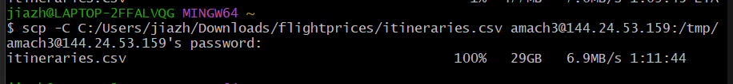

* Download the airport.csv file from Kaggle and unzip it in Download folder. Then secure copy it to linux.

scp C:/Users/jiazh/Downloads/airportcode/airports.csv amach3@144.24.53.159:/home/amach3



1. **Copy files from linux server to hdfs**

* Make FlightData directory and put itineraries.csv file here

hdfs dfs -mkdir FlightData

hdfs dfs -put /tmp/itineraries.csv /user/amach3/FlightData/

hdfs dfs -ls FlightData/



* Make the FlightData directory public

hdfs dfs -chmod -R go+rx /user/amach3/FlightData

* Make Airport directory and put Airport.csv file here

hdfs dfs -mkdir Airport

hdfs dfs -put airports.csv Airport/

hdfs dfs -ls Airport/

* make the Airport directory public

hdfs dfs -chmod -R go+rx /user/amach3/Airport

1. **Create tables in Hive**

Beeline

Use amach3;

DROP TABLE IF EXISTS Airport;

CREATE EXTERNAL TABLE IF NOT EXISTS Airport

(Name string, City string, Country string, IATA string, ICAO string,

Latitude double, Longitude double)

ROW FORMAT DELIMITED FIELDS TERMINATED BY ','

STORED AS TEXTFILE LOCATION '/user/amach3/Airport/'

TBLPROPERTIES ('skip.header.line.count'='1');

SELECT * FROM Airport LIMIT 10;

DROP TABLE IF EXISTS FlightData;

CREATE EXTERNAL TABLE IF NOT EXISTS FlightData

(FlightID string, SearchDate date, FlightDate date, StartingAirport string,

DestinationAirport string, FareBasisCode string, TravelDuration string,

ElapsedDays int, IsBasicEconomy boolean, IsRefundable boolean,

IsNonStop boolean, BaseFare double, TotalFare double, SeatsRemaining int,

TotalTravelDistance double, SegmentsDepartureTimeEpochSeconds string,

SegmentsDepartureTimeRaw string, SegmentsArrivalTimeEpochSeconds string,

SegmentsArrivalTimeRaw string, SegmentsArrivalAirportCode string,

SegmentsDepartureAirportCode string, SegmentsAirlineName string,

SegmentsAirlineCode string, SegmentsEquipmentDescription string,

SegmentsDurationInSeconds string, SegmentsDistance double,

SegmentsCabinCode string)

ROW FORMAT DELIMITED FIELDS TERMINATED BY ','

STORED AS TEXTFILE LOCATION '/user/amach3/FlightData/'

TBLPROPERTIES ('skip.header.line.count'='1');

SELECT * FROM FlightData LIMIT 2;

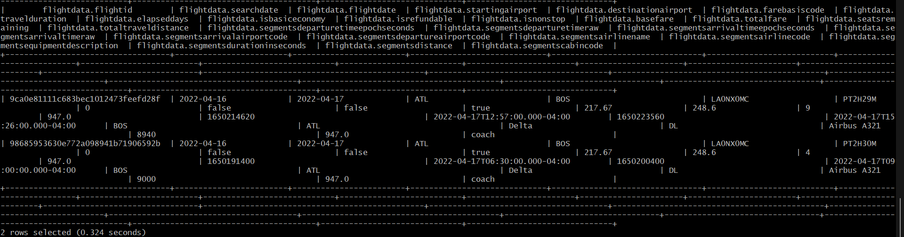

Since the dataset is too large, Dr. Woo advised us to reduce our data size to 2 – 3 GB by sampling our data.

SELECT COUNT(*) FROM FlightData; --82138753 rows

--10% is about 8,000,000 rows

CREATE EXTERNAL TABLE IF NOT EXISTS FlightData2

(FlightID string, SearchDate date, FlightDate date, StartingAirport string,

DestinationAirport string, FareBasisCode string, TravelDuration string,

ElapsedDays int, IsBasicEconomy boolean, IsRefundable boolean,

IsNonStop boolean, BaseFare double, TotalFare double, SeatsRemaining int,

TotalTravelDistance int, SegmentsDepartureTimeEpochSeconds string,

SegmentsDepartureTimeRaw string, SegmentsArrivalTimeEpochSeconds string,

SegmentsArrivalTimeRaw string, SegmentsArrivalAirportCode string,

SegmentsDepartureAirportCode string, SegmentsAirlineName string,

SegmentsAirlineCode string, SegmentsEquipmentDescription string,

SegmentsDurationInSeconds string, SegmentsDistance int,

SegmentsCabinCode string)

ROW FORMAT DELIMITED FIELDS TERMINATED BY ','

STORED AS TEXTFILE LOCATION '/user/amach3/FlightData2/'

TBLPROPERTIES ('skip.header.line.count'='1');

INSERT OVERWRITE TABLE FlightData2

SELECT * FROM FlightData

WHERE rand() <= 0.1

distribute by rand()

SORT BY rand()

LIMIT 8000000;

SELECT COUNT(*) FROM FlightData2;

1. **Data Engineering**
2. Drop unusable columns

ALTER TABLE FlightData2 REPLACE COLUMNS (FlightID string, SearchDate date, FlightDate date, StartingAirport string,

DestinationAirport string, FareBasisCode string, TravelDuration string,

ElapsedDays int, IsBasicEconomy boolean, IsRefundable boolean,

IsNonStop boolean, BaseFare double, TotalFare double, SeatsRemaining int,

TotalTravelDistance int, SegmentsAirlineName string, SegmentsEquipmentDescription string);

SELECT * FROM FlightData2 LIMIT 2;

1. Remove any duplicate rows from FlightData2 table

INSERT OVERWRITE TABLE FlightData2

SELECT DISTINCT * FROM FlightData2;

-- Check number of rows after removing duplicates

SELECT COUNT(*) FROM FlightData2;

1. Check null values

SELECT COUNT(*) FROM FlightData2 where TotalTravelDistance IS NULL;

SELECT count(*) from FlightData2 where FlightDate IS NULL;

SELECT count(*) from FlightData2 where StartingAirport IS NULL;

SELECT count(*) from FlightData2 where DestinationAirport IS NULL;

SELECT count(*) from FlightData2 where TravelDuration IS NULL;

SELECT count(*) from FlightData2 where IsBasicEconomy IS NULL;

SELECT count(*) from FlightData2 where IsNonStop IS NULL;

SELECT count(*) from FlightData2 where BaseFare IS NULL;

SELECT count(*) from FlightData2 where TotalFare IS NULL;

SELECT count(*) from FlightData2 where SeatsRemaining IS NULL;

SELECT count(*) from FlightData2 where SegmentsAirlineName IS NULL;

SELECT count(*) from FlightData2 where SegmentsEquipmentDescription IS NULL;

Since our dataset is huge (almost 8 million rows of data), we decided to remove rows with null values detected above.

INSERT OVERWRITE TABLE FlightData2

SELECT * FROM FlightData2 WHERE TotalTravelDistance IS NOT NULL;

INSERT OVERWRITE TABLE FlightData2

SELECT * FROM FlightData2 WHERE FlightDate IS NOT NULL;

INSERT OVERWRITE TABLE FlightData2

SELECT * FROM FlightData2 WHERE StartingAirport IS NOT NULL;

INSERT OVERWRITE TABLE FlightData2

SELECT * FROM FlightData2 WHERE DestinationAirport IS NOT NULL;

INSERT OVERWRITE TABLE FlightData2

SELECT * FROM FlightData2 WHERE TravelDuration IS NOT NULL;

INSERT OVERWRITE TABLE FlightData2

SELECT * FROM FlightData2 WHERE IsBasicEconomy IS NOT NULL;

INSERT OVERWRITE TABLE FlightData2

SELECT * FROM FlightData2 WHERE IsNonStop IS NOT NULL;

INSERT OVERWRITE TABLE FlightData2

SELECT * FROM FlightData2 WHERE BaseFare IS NOT NULL;

INSERT OVERWRITE TABLE FlightData2

SELECT * FROM FlightData2 WHERE TotalFare IS NOT NULL;

INSERT OVERWRITE TABLE FlightData2

SELECT * FROM FlightData2 WHERE SeatsRemaining IS NOT NULL;

INSERT OVERWRITE TABLE FlightData2

SELECT * FROM FlightData2 WHERE SegmentsAirlineName IS NOT NULL;

INSERT OVERWRITE TABLE FlightData2

SELECT * FROM FlightData2 WHERE SegmentsEquipmentDescription IS NOT NULL;

SELECT COUNT(*) from FlightData2;

1. Add FlightMonth column by getting the month from FlightDate column

ALTER TABLE FlightData2 ADD COLUMNS (FlightMonth int);

INSERT OVERWRITE TABLE FlightData2

SELECT FlightID, SearchDate, FlightDate, StartingAirport,

DestinationAirport, FareBasisCode string, TravelDuration,

ElapsedDays, IsBasicEconomy, IsRefundable,

IsNonStop, BaseFare, TotalFare, SeatsRemaining,

TotalTravelDistance, SegmentsAirlineName , SegmentsEquipmentDescription,

MONTH(FlightDate) AS FlightMonth FROM FlightData2;

SELECT FlightDate, FlightMonth FROM FlightData2 LIMIT 10;

1. Add a FlightRoute column that concatenate startingAirport with destinationAirport columns

ALTER TABLE FlightData2 ADD COLUMNS (FlightRoute string);

INSERT OVERWRITE TABLE FlightData2

SELECT FlightID, SearchDate, FlightDate, StartingAirport,

DestinationAirport, FareBasisCode string, TravelDuration,

ElapsedDays, IsBasicEconomy, IsRefundable,

IsNonStop, BaseFare, TotalFare, SeatsRemaining,

TotalTravelDistance, SegmentsAirlineName , SegmentsEquipmentDescription, FlightMonth,

CONCAT(StartingAirport, '-', DestinationAirport) AS FlightRoute

FROM FlightData2;

SELECT StartingAirport, DestinationAirport, FlightRoute FROM FlightData2 limit 10;

1. **Write analysis queries, export result to HDFS, secure copy text files to local computer, and create visualizations.**
2. Top 10 most popular flight routes

INSERT OVERWRITE DIRECTORY '/user/amach3/FlightData2/FlightRoute/'

ROW FORMAT DELIMITED FIELDS TERMINATED BY ','

SELECT FlightRoute, COUNT(FlightID) AS FlightCount

FROM FlightData2

GROUP BY FlightRoute

ORDER BY FlightCount DESC

LIMIT 10;

hdfs dfs -get /user/amach3/FlightData2/FlightRoute/000000_0 FlightRoute.txt

scp [amach3@144.24.53.159:/home/amach3/FlightRoute.txt FlightRoute.txt](mailto:amach3@144.24.53.159:/home/amach3/FlightRoute.txt%20FlightRoute.txt)

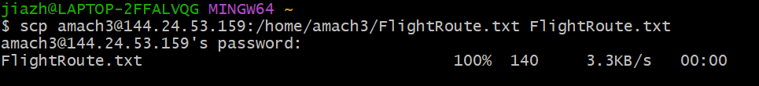

1. Least 10 popular flight routes

INSERT OVERWRITE DIRECTORY '/user/amach3/FlightData2/LeastPopularRoute/'

ROW FORMAT DELIMITED FIELDS TERMINATED BY ','

SELECT FlightRoute, COUNT(FlightID) AS FlightCount

FROM FlightData2

GROUP BY FlightRoute

ORDER BY FlightCount ASC

LIMIT 10;

hdfs dfs -get /user/amach3/FlightData2/LeastPopularRoute/000000_0 LeastPopularRoute.txt

scp amach3@144.24.53.159:/home/amach3/LeastPopularRoute.txt LeastPopularRoute.txt



1. Top 15 most expensive routes

INSERT OVERWRITE DIRECTORY '/user/amach3/FlightData2/FlightPrice/'

ROW FORMAT DELIMITED FIELDS TERMINATED BY ','

SELECT FlightRoute, ROUND(AVG(TotalFare),2) AS FlightPrice

FROM FlightData2

GROUP BY FlightRoute

ORDER BY FlightPrice DESC LIMIT 15;

hdfs dfs -get /user/amach3/FlightData2/FlightPrice/000000_0 FlightPrice.txt

scp amach3@144.24.53.159:/home/amach3/FlightPrice.txt FlightPrice.txt

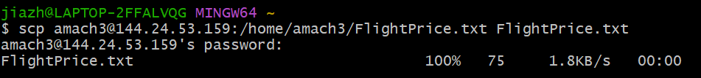

1. Airfare and Travel Distance over time

INSERT OVERWRITE DIRECTORY '/user/amach3/FlightData2/PriceDistanceOverTime/'

ROW FORMAT DELIMITED FIELDS TERMINATED BY ','

SELECT FlightMonth, ROUND(AVG(TotalFare),2) AS AverageAirfare, ROUND(AVG(TotalTravelDistance),2) AS AverageTravelDistance

FROM FlightData2

GROUP BY FlightMonth;

hdfs dfs -ls /user/amach3/FlightData2/PriceDistanceOverTime

hdfs dfs -get /user/amach3/FlightData2/PriceDistanceOverTime/000000_0

hdfs dfs -get /user/amach3/FlightData2/PriceDistanceOverTime/000001_0

hdfs dfs -get /user/amach3/FlightData2/PriceDistanceOverTime/000002_0

hdfs dfs -get /user/amach3/FlightData2/PriceDistanceOverTime/000003_0

cat 000000_0 000002_0 000003_0 000001_0 > PriceDistanceOverTime.txt

scp amach3@144.24.53.159:/home/amach3/ PriceDistanceOverTime.txt PriceDistanceOverTime.txt

1. Which are the most popular destinations over the months?

INSERT OVERWRITE DIRECTORY '/user/amach3/FlightData2/Destination/'

ROW FORMAT DELIMITED FIELDS TERMINATED BY ','

SELECT DestinationAirport, date_format(FlightDate,'MM-01-yyyy') AS formatted_date,Latitude, Longitude, COUNT(FlightID) AS FlightCount

FROM FlightData2 F

JOIN Airport A

ON F.DestinationAirport = A.IATA

GROUP BY DestinationAirport,date_format(FlightDate,'MM-01-yyyy'), Latitude, Longitude;

hdfs dfs -get /user/amach3/FlightData2/Destination/000000_0

hdfs dfs -get /user/amach3/FlightData2/Destination/000001_0

hdfs dfs -get /user/amach3/FlightData2/Destination/000002_0

hdfs dfs -get /user/amach3/FlightData2/Destination/000003_0

hdfs dfs -get /user/amach3/FlightData2/Destination/000004_0

hdfs dfs -get /user/amach3/FlightData2/Destination/000005_0

hdfs dfs -get /user/amach3/FlightData2/Destination/000006_0

hdfs dfs -get /user/amach3/FlightData2/Destination/000007_0

hdfs dfs -get /user/amach3/FlightData2/Destination/000008_0

hdfs dfs -get /user/amach3/FlightData2/Destination/000009_0

hdfs dfs -get /user/amach3/FlightData2/Destination/000010_0

hdfs dfs -get /user/amach3/FlightData2/Destination/000011_0

cat 000000_0 000002_0 000003_0 000001_0 000004_0 000005_0 000006_0 000007_0 000008_0 000009_0 000010_0 000011_0 > Destination.txt



scp amach3@144.24.53.159:/home/amach3/Destination.txt Destination.txt

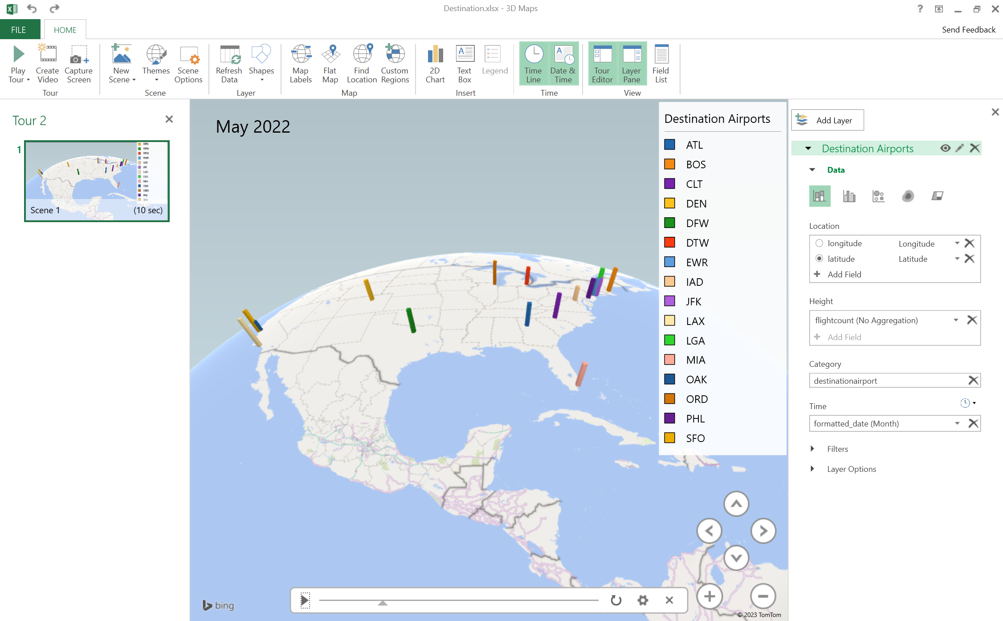

1. Distribution of basic economy tickets

INSERT OVERWRITE DIRECTORY '/user/amach3/FlightData2/BasicEconomy/'

ROW FORMAT DELIMITED FIELDS TERMINATED BY ','

SELECT isBasicEconomy, COUNT(*) as count

FROM FlightData2

GROUP BY isBasicEconomy;

hdfs dfs -ls /user/amach3/FlightData2/BasicEconomy

hdfs dfs -get /user/amach3/FlightData2/BasicEconomy/000000_0

hdfs dfs -get /user/amach3/FlightData2/BasicEconomy/000001_0

cat 000000_0 000001_0 > BasicEconomy.txt

scp amach3@144.24.53.159:/home/amach3/BasicEconomy.txt BasicEconomy.txt



